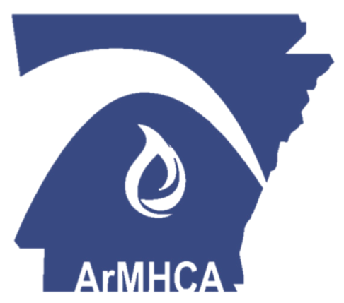
ARKANSAS MENTAL HEALTH

COUNSELORS ASSOCIATION

SPONSOR
VENDOR
PACKET

WWW.ARMHCA.ORG

Hello, and thank you for your interest in

WWW.ARMHCA.ORG
Arkansas Mental Health Counselors Association!

We appreciate your interest in further learning about Arkansas Mental Health Counselors Association (ArMHCA). This letter is to provide you with information regarding our organization as well as presenting unique sponsorship opportunities. ArMHCA has been a non profit organization for over 30 years and the purpose is to serve as the collective voice of licensed mental health counselors in Arkansas. Our organization prides itself on advocating, educating, leading, and collaborating with and for mental health professionals locally and nationally under the American Mental Health Counselors Association (AMHCA) umbrella.
ArMHCA is one of the leading continuing education providers in our state by offering a fall retreat and large conference in the spring to all mental health counselors in the state. The fall retreat provides members an important self-care getaway to maintain the desire to make a difference in others. The annual conference is a great opportunity for the mental health professionals around the state to gather in one location in order to network and renew concepts most concerning to the licensed community.
Please reference the enclosed sponsorship packet.
Sincerely,
Beth Forst, LPC
Conference Co-Chair
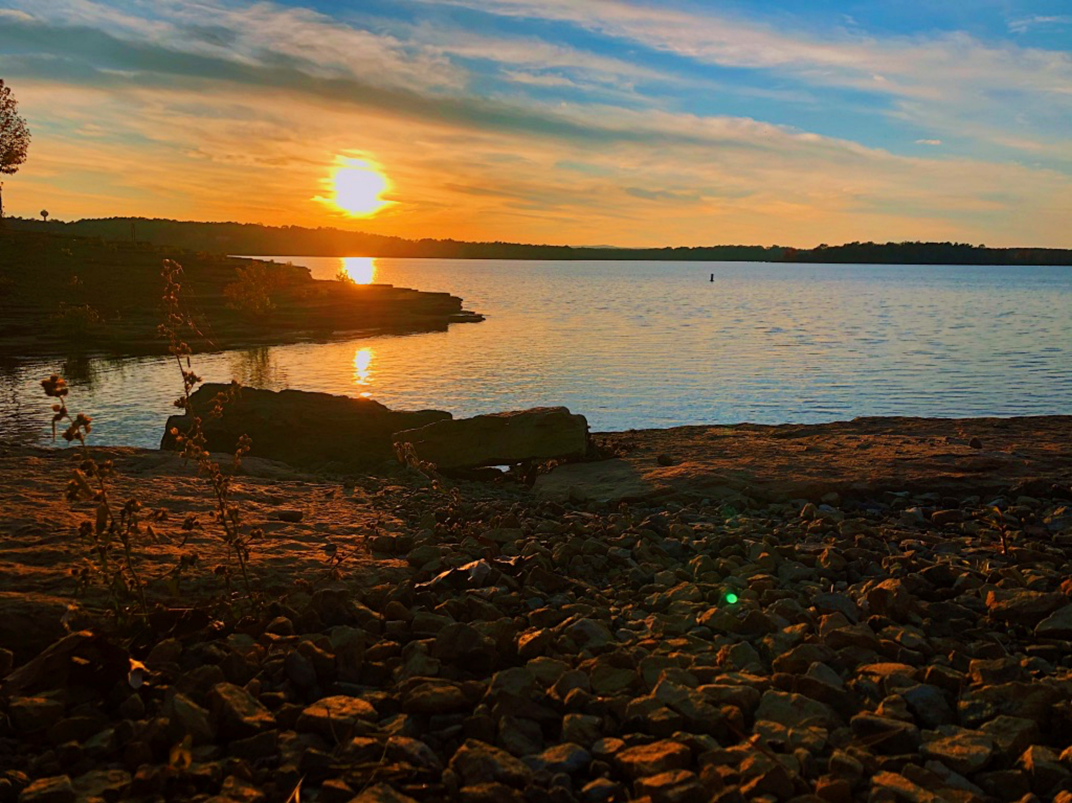
WWW.ARMHCA.ORG

ArMHCA RETREAT SPONSORSHIP OPPORTUNITIES
LUNCH SPONSOR ($1000) 1 SPONSOR
Vendor table at retreat to market product or business
Opportunity to briefly speak during lunch in order to promote or educate audience regarding product or business
Recognition during sessions
Logo displayed on website for 90 days beginning on October 1st
REFRESHMENT SPONSOR ($300) 2 SPONSORS
Vendor table at retreat to market product or business
Provides refreshments during breakfast and breaks Saturday
Recognition during sessions
Logo displayed on website for 45 days beginning on October 1st
TABLE SPONSOR ($200) 10 SPONSORS
Vendor table at retreat to market product or business
Logo displayed on website for 30 days beginning on October 1st

PRIVATE PRACTICE SPONSOR ($75)
Only for practices with 1-4 clinicians
Vendor table at retreat to market product or business
Logo displayed on website for 30 days beginning on October 1st

WWW.ARMHCA.ORG

ROOM RESERVATIONS

Contact the Winthrop Rockefeller Institute
at (501) 727-5435 and mention you are with
ArMHCA RETREAT
ROOM RESERVATIONS

Winthrop Rockefeller Institute
1 Rockefeller Dr, Morrilton, AR
September 20th, 2025
PLEASE CONTACT bethforst21@gmail.com WITH QUESTIONS

Please complete the following packet and send to bethforst21@gmail.com.

Organization name:

Contact person:

Email: Phone Number:

YOUR SPONSORSHIP PLAYS A LARGE ROLE IN THE
SUCCESS OF OUR MISSION TO EDUCATE, CONNECT, AND ADVOCATE MENTAL HEALTH PROFESSIONALS ACROSS THE STATE.
Sponsorship Type (please check one):

- Lunch Sponsor ($1000)
- Refreshment Sponsor ($300)
- Table Sponsor ($200)
- Private Practice Sponsor ($75)


Payment Type (please check one):

- Check
- Card
- Paypal

WWW.ARMHCA.ORG

